Process/ Schematic/ System Diagram

1. Fuel System

The fuel system of a power plant provides and prepares the fuel for burning in the combustor. The proposed power plant will be using a sub-bituminous coal which is widely used in generating steam power and industrial purposes. It contains less sulfur but more moisture approximately 10 to 45 percent than other bituminous coal types. Sub-bituminous coal produces ash that has higher alkaline content than other coal ash that can help reduce acid rain typically caused by coal-fired power plant emissions.

Fuel of the power plant will be produced by Semirara Mining and Power Corporation which owns and mines its own fuel source (coal). The corporation produces sub-bituminous coal that is appropriate for use in a wide range of combustion facilities.

2. Transport System

The proposed power plant will use a sub-bituminous coal which will be produced by Semirara Mining and Power Corporation. Coal will be shipped to the port area where it will be conveyed in the coal storage for future use. It is important to consider the transport system for it has a part in the investment costs which is the transport cost. Available rod will also be considered for easy transportation which is one of the parameters in choosing the best location for the proposed power plant.

Semirara Mining and Power Corporation is located at Caluya, Antique which is more than 300 km from Lian, Batangas.

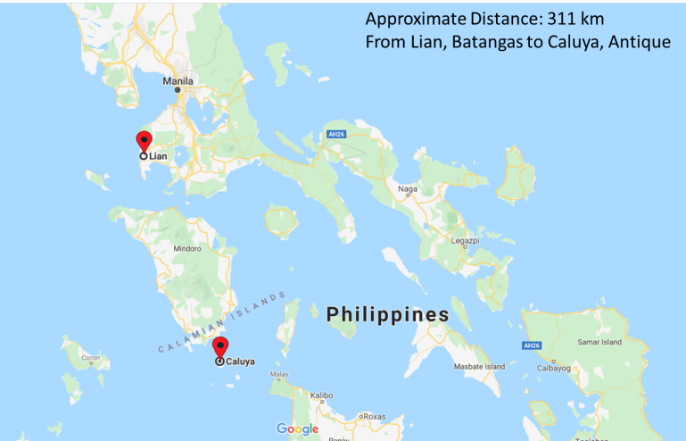

**Figure _.** Transport System

3. Exhaust System

The inlet and exhaust pressures and inlet temperature of the steam in a steam engine determine the potential energy required at the turbine inlet. Water moves over an alternating series of fixed and rotating blades to release the energy inside the turbine and as a result extends from high pressure to low pressure.

The HRSG absorbs heat from the exhaust gas turbine to produce steam at temperatures up to ~650 ° C, and 13–20 MPa pressure. While SC systems have been developed, the generation of heat recovery steam is most frequently applied under subcritical conditions.

4. Storage System

It is important that adequate quantity of coal should be stored. Coal storage offers protection against coal supply disruption when there is delay in coal transport or strike in coal mines. The coal may also be bought and stored for future use, if the prices are low. The amount of coal to be stored depends on the availability of storage space, transportation facilities, the amount of coal to be stored on the power station both away from and close to coal mines.

Usually coal needed for one month of power plant service is stored in the case of power plants located at a longer distance from the collieries while coal need is stored for around 15 days in the case of power plants located close to collieries. Coal storage is not desirable for longer periods as it blocks the capital and results in a loss of coal quality.

5. Instrumentation and Control System

In order for a power plant to run efficiently, it is important to consider the instrumentation and control system which plays a major role in profitable operation of a plant. This system includes the sensors that can detect the measured values and controllers which receive these values. New coal-fired power plants are built with modern and advanced systems that can help in achieving the maximum efficiency of a power plant. It can also reduce the maintenance costs through better monitoring of plant equipment condition and detect equipment malfunctions that may lead to power plant shutdown.

6. Water Treatment System

Water treatment for generating electricity is a critical process which needs a reliable technology. High purity water ensures proper steam generation system operation, and reduces blowdown frequency and boiler chemicals usage. High purity water can also protect better against erosion and equipment destruction. When the operational pressure of the power plant rise, the demands on water quality do become more stringent. The specifications are strict for the existing equipment running at Supercritical pressures. Continuous developments and changes in techniques of preserving water quality, understanding the processes of degradation and discovering new additives have resulted in a more sustainable and effective operation of the water system.

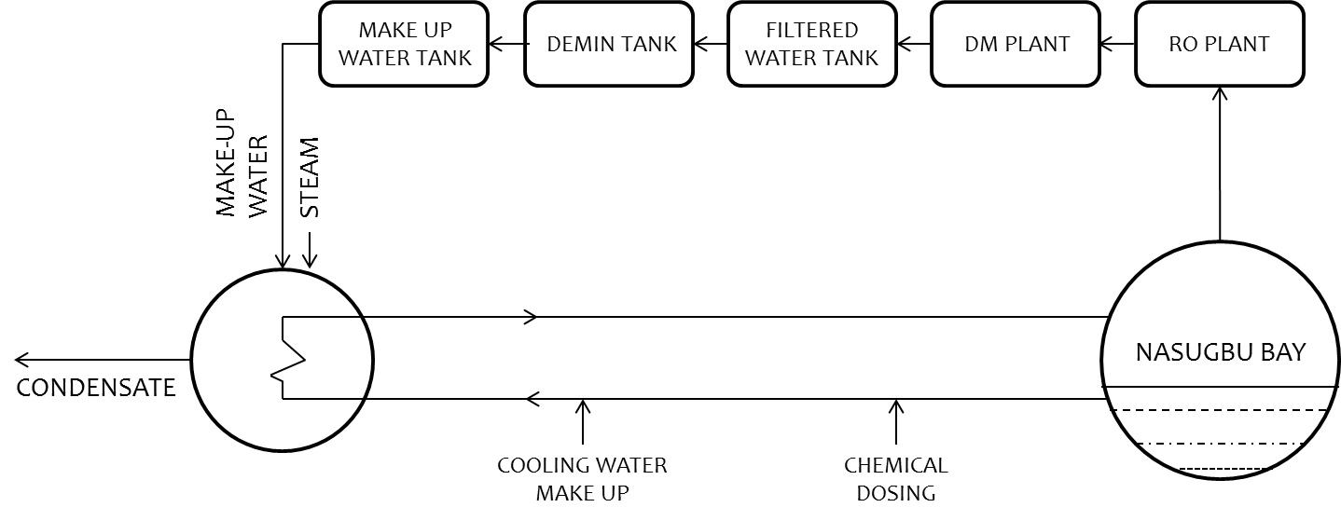

**Figure _.** Water Treatment System Diagram

7. Cooling System

All steam power plants work by heating water in the boiler until it turns into steam. The steam is then used to spin the turbine, which then drives an attached generator, which produces electricity. Water used by the condenser to cool the steam is withdrawn from nearby rivers, lakes, and other bodies of water which are near to the plant; that is the Nasugbu Bay for the proposed design. Surrounding bodies of water is one of the parameters considered in choosing the best location for the proposed power plant for an easy access of water for the cooling system.

8. Ash Handling System

Pulverized coal burning boilers (PC) have furnaces at the bottom. Under the boiler, the large ash particles are stored in a water-filled ash hopper, Fly-ash is stored with either an electrostatic precipitator or a baghouse in dust collector. A PC boiler contains around 80% fly ash and 20% bottom ash. Ash must be collected and transported from various plant locations, as shown in figure. Pyrites, which are the pulverizer rejections, are disposed of with the ash device at the edges. Three major factors for the ash disposal systems should be considered such as, Plant sites, Fuel source and Environmental regulation. For many ash management systems needs for water and land are essential considerations. The amounts of ash to be disposed of depend on the king of fuel. Sites where ash is stored and disposed of are regulated by environmental legislation.